flyaway flights booking engine

Author- Malini.Murthy

flights booking engine screen shots

Author- Malini.murthy

Project- flyaway flights booking engine

Screens:

Intelij steup and tomcat running;

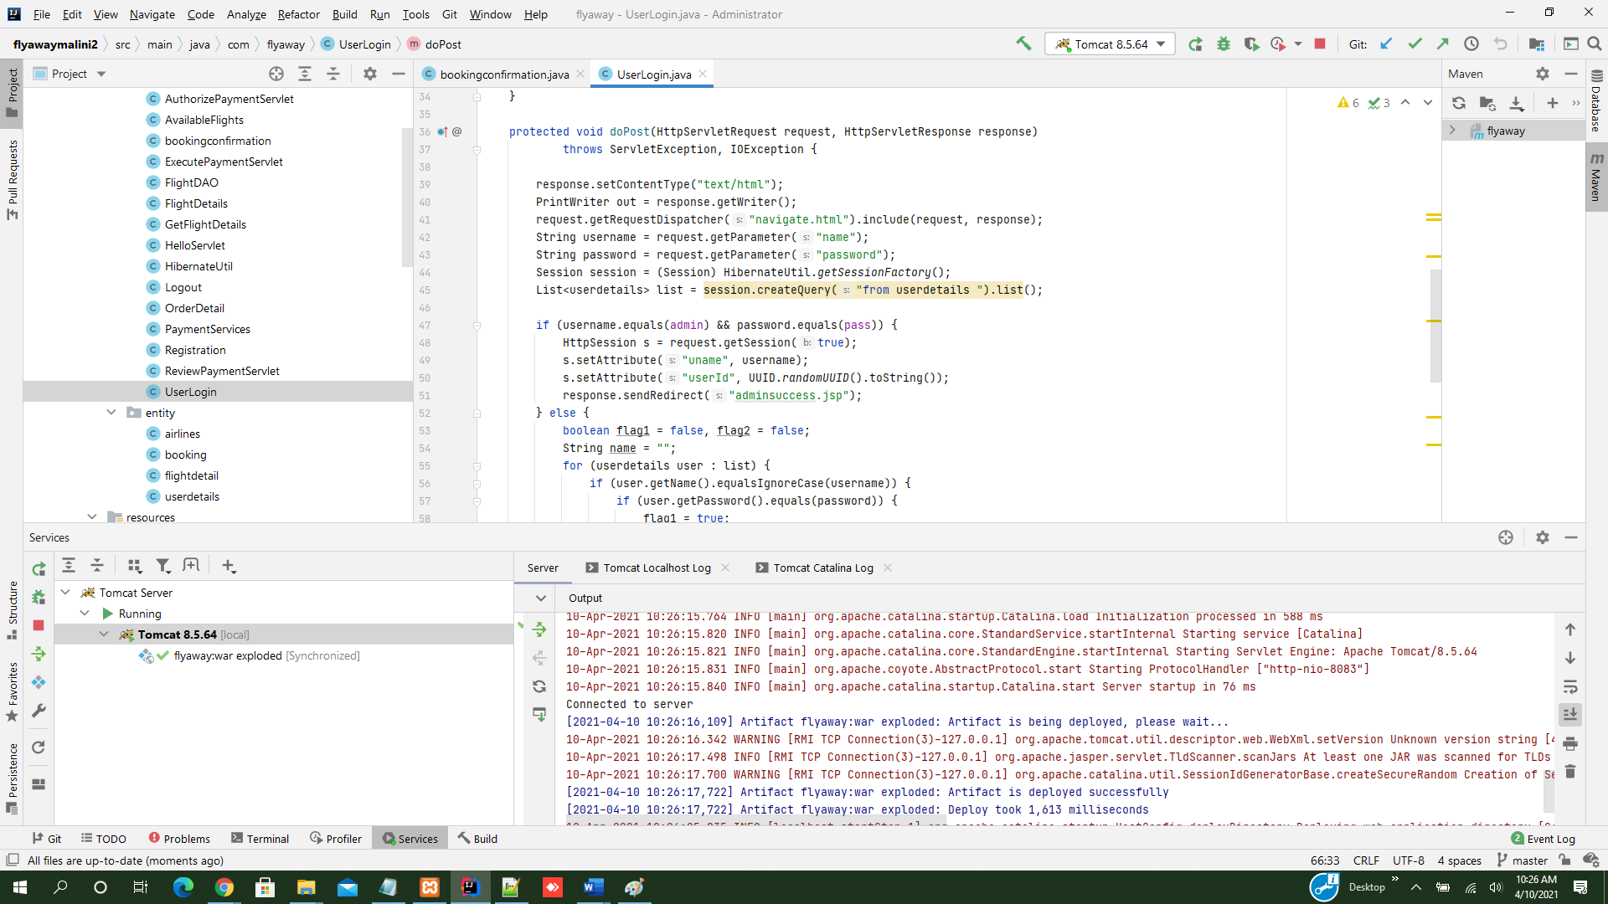

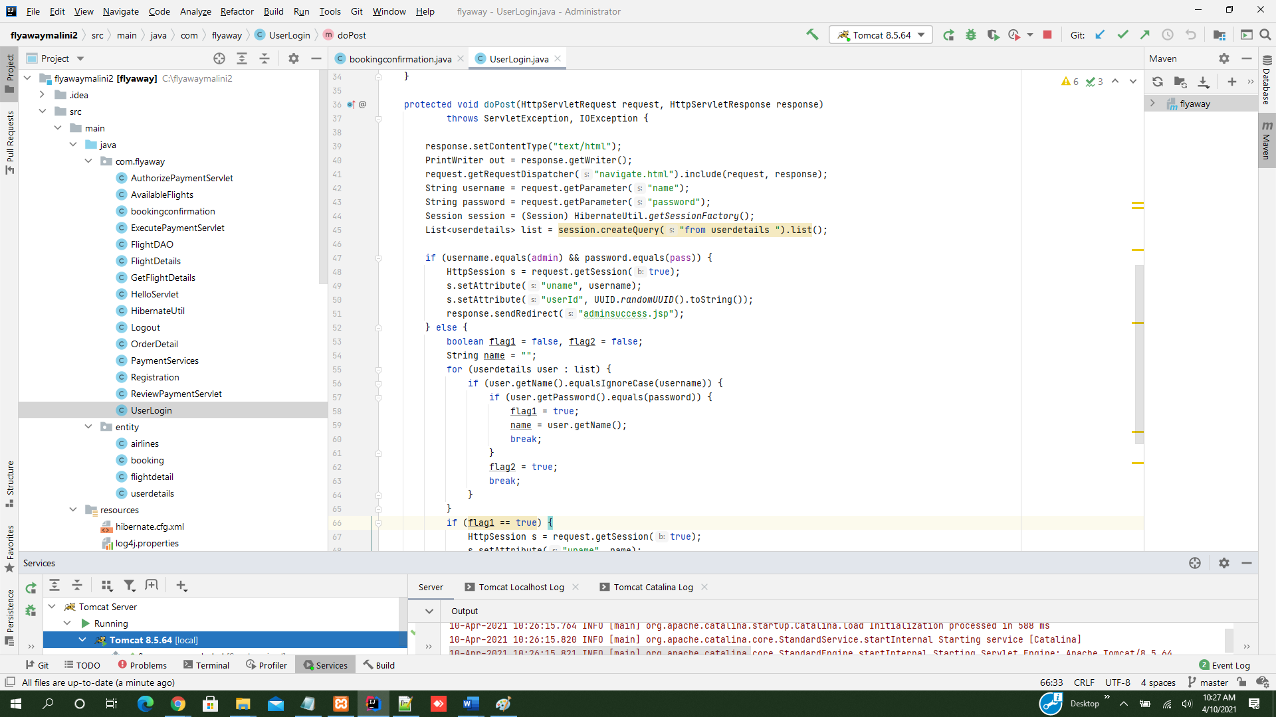

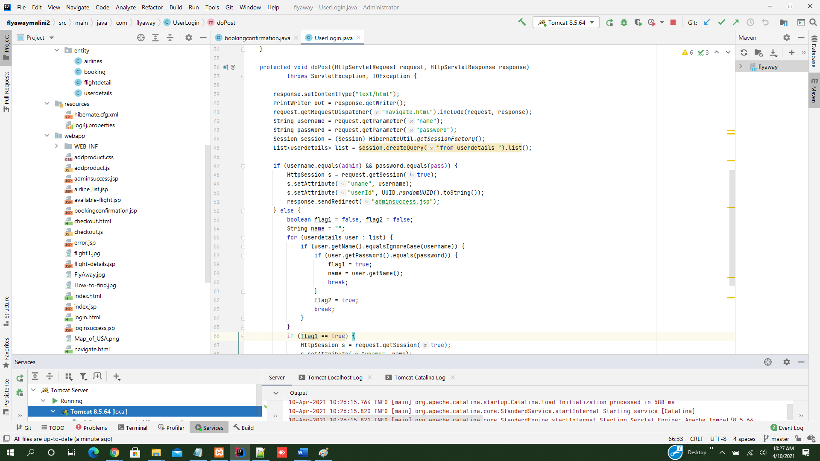

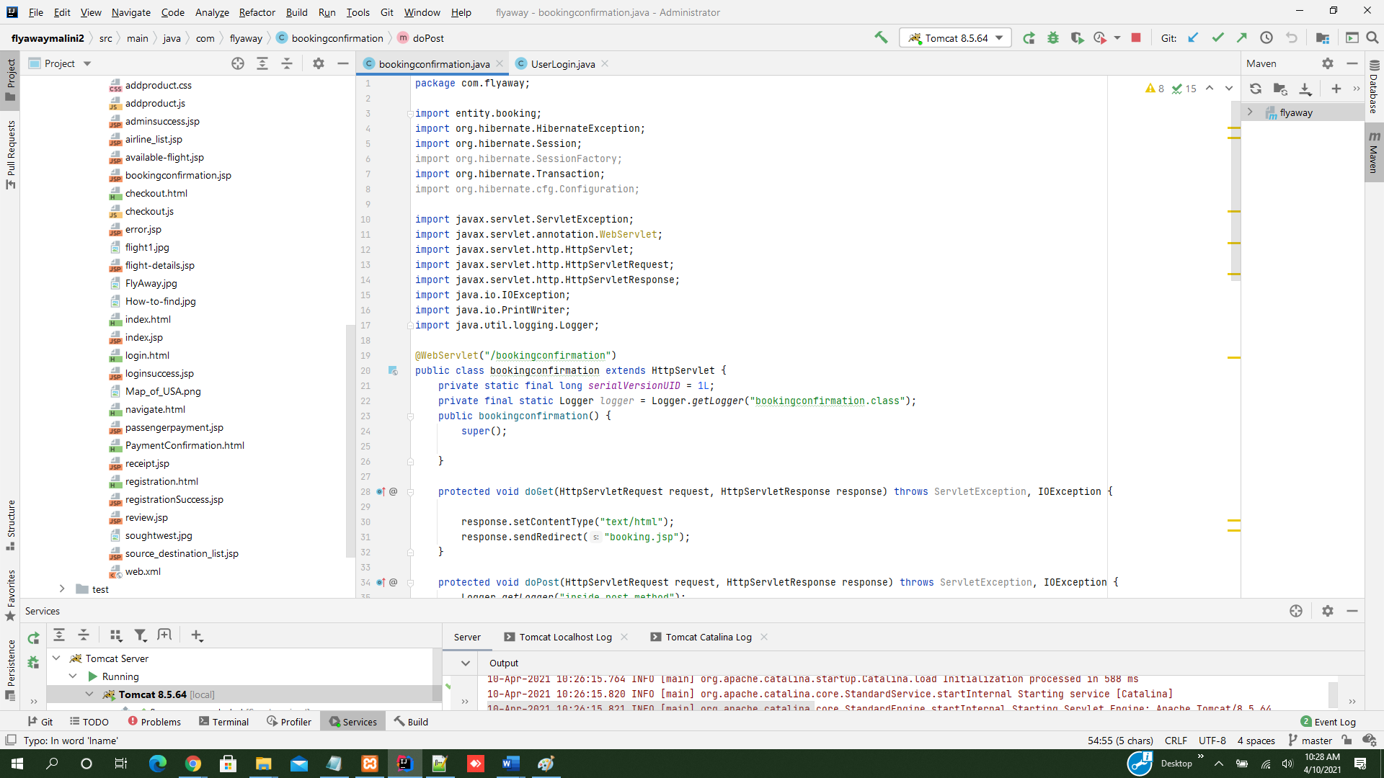

1. flyaway consumer Product launched

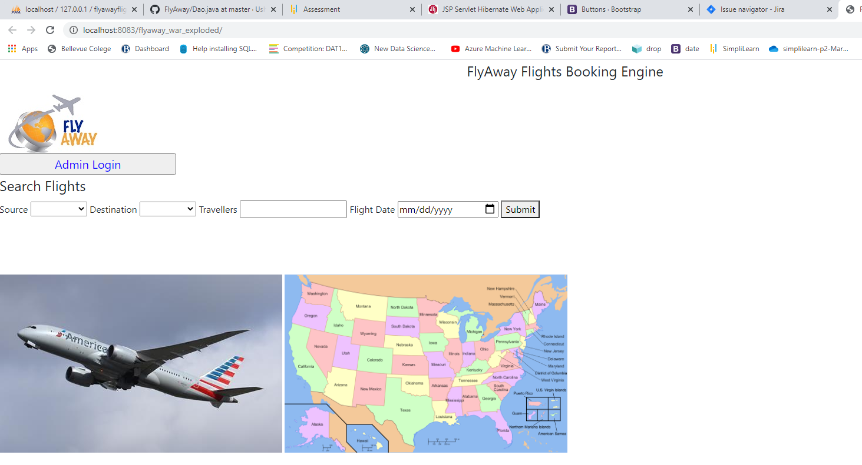

1. login

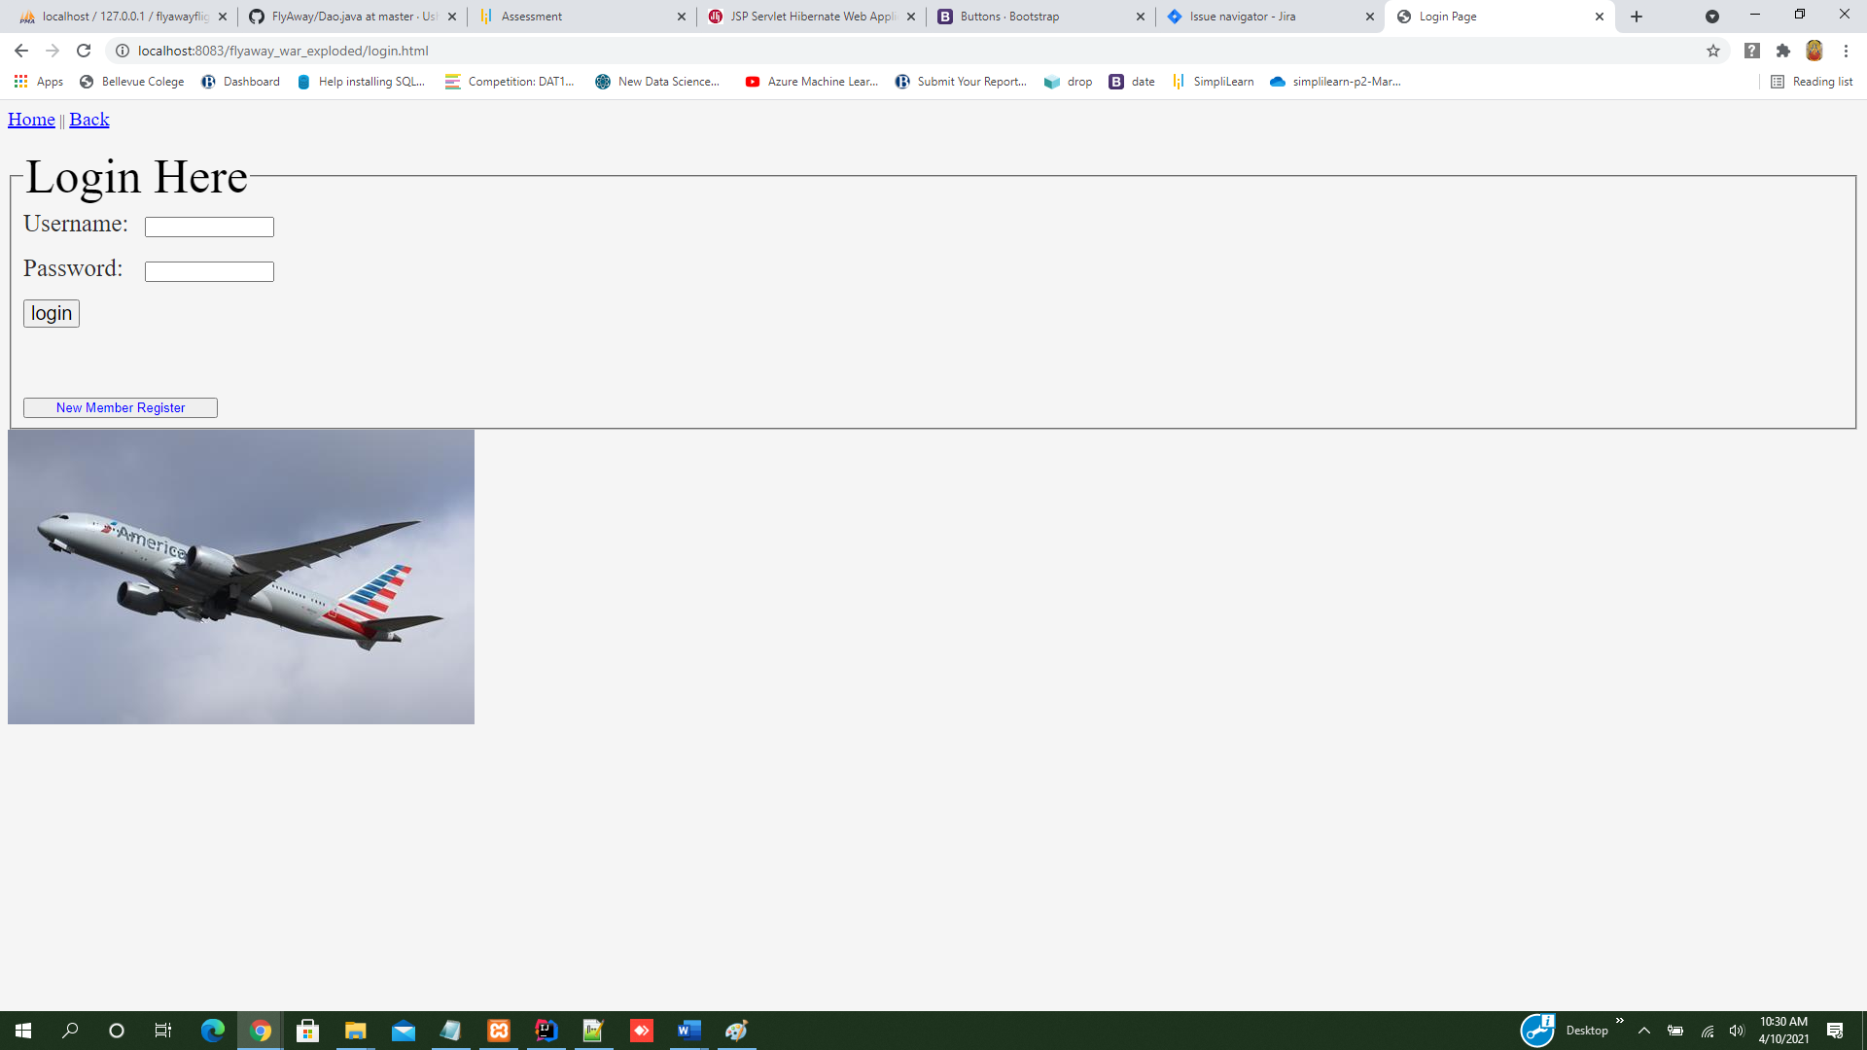

1. login

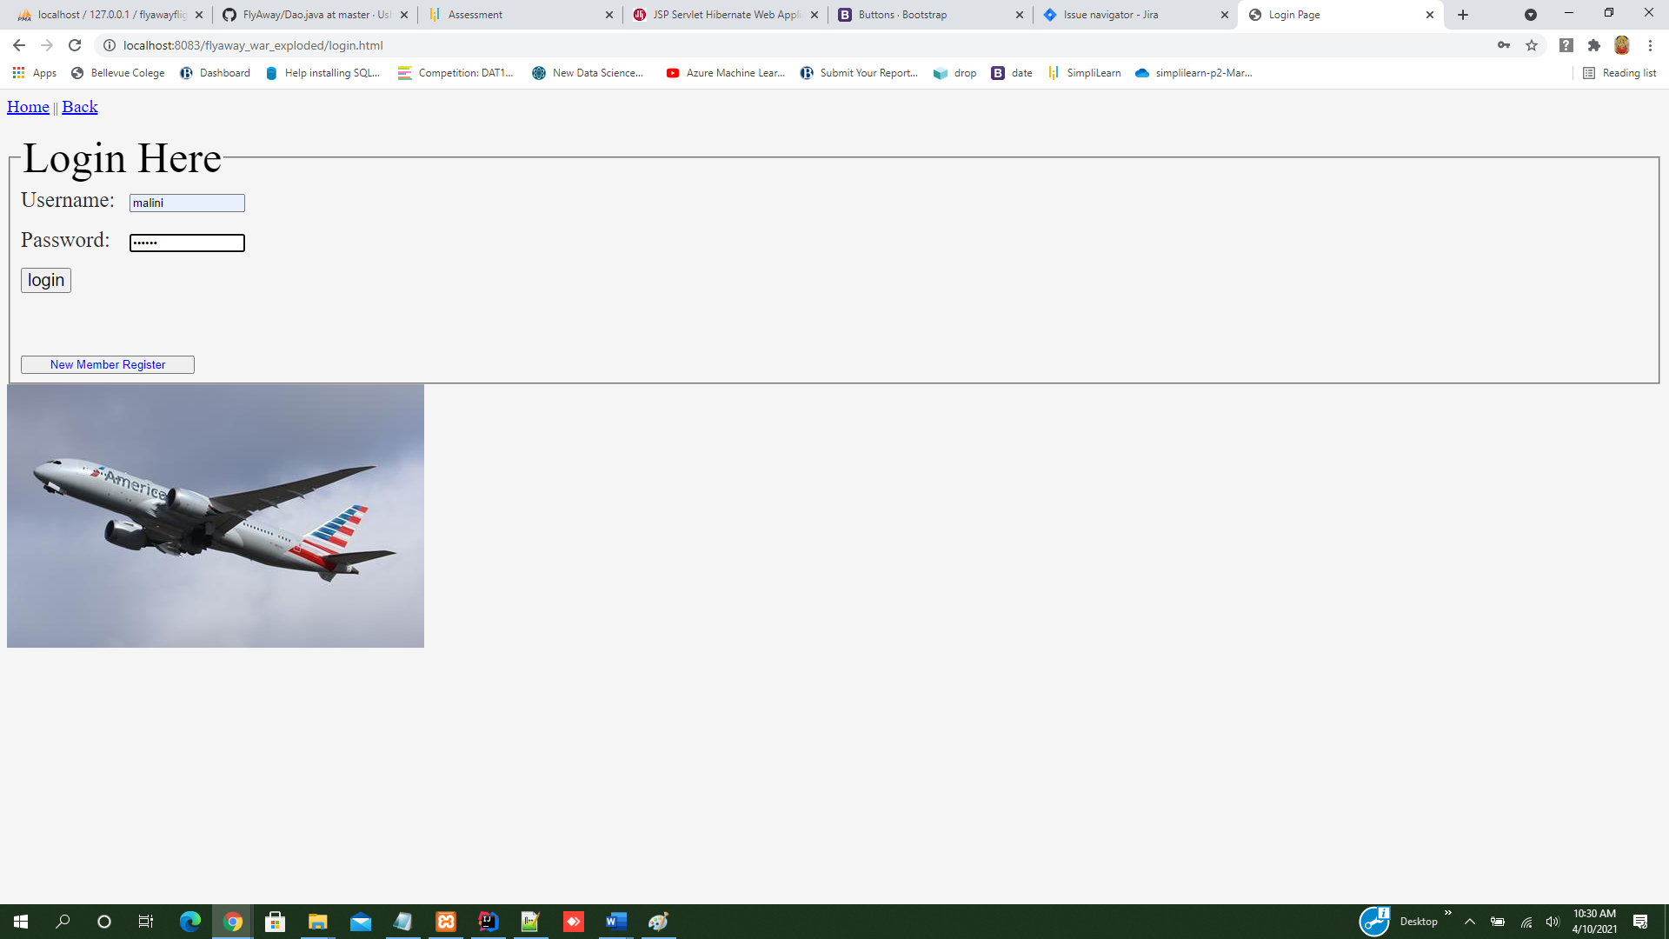

1. new member registration

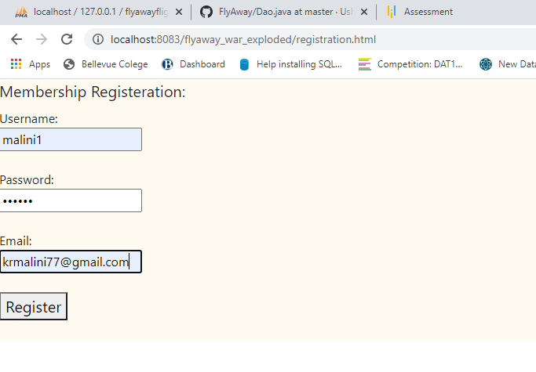

1. User added
2. 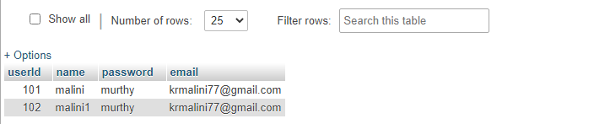
3. Airline details

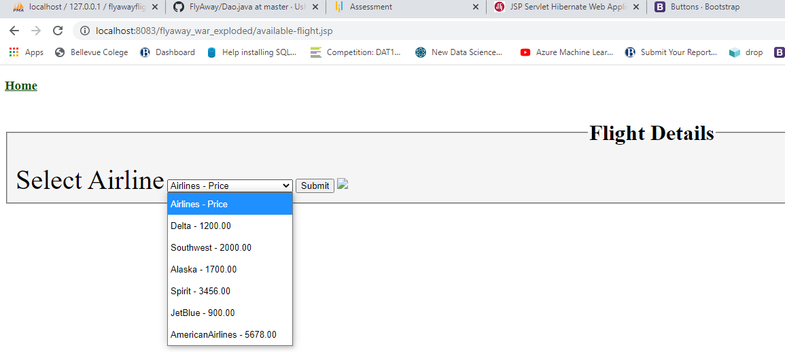

1. Flights Search

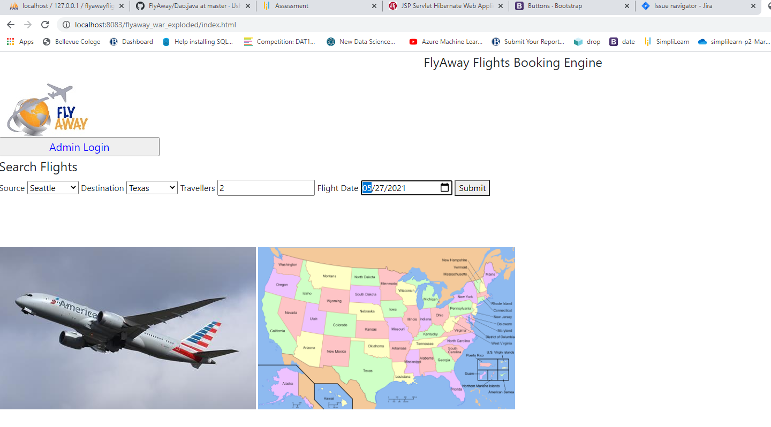

1. Fight search landing page

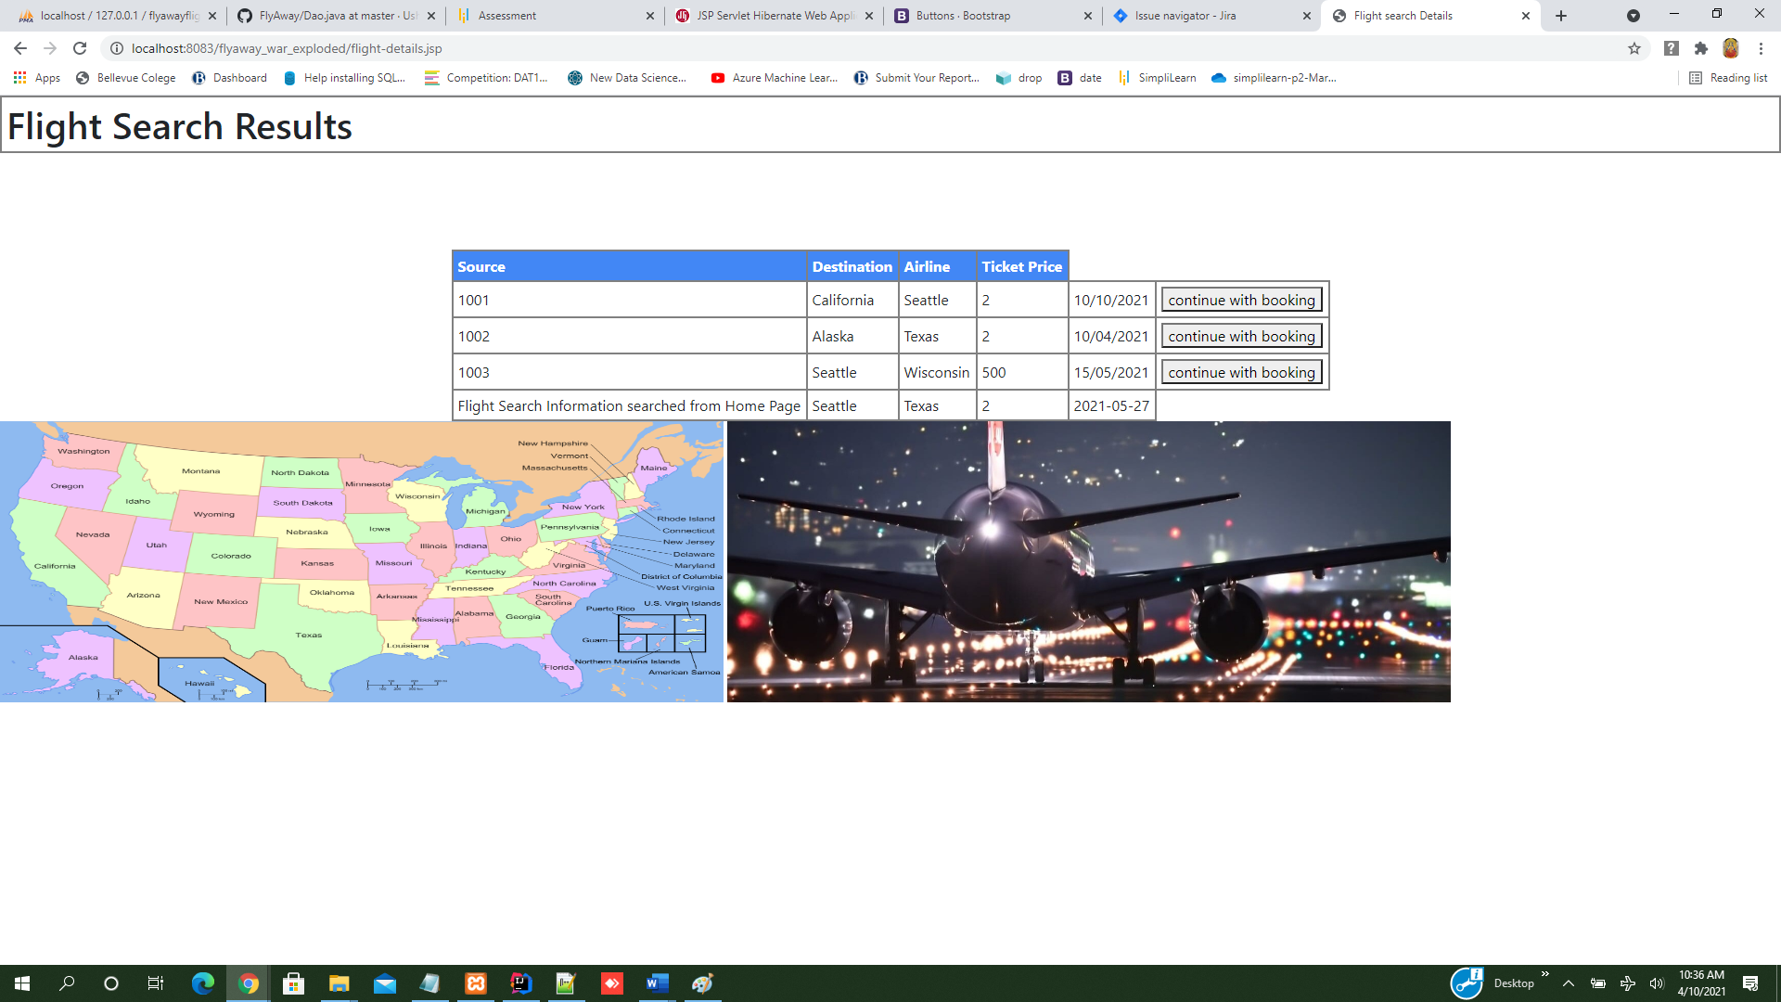

1. Select any package and continue
   1. payment and booking confirmation saving to db
   2. check out using paypal sandbox testing API integration

booking is achieved through both ways;

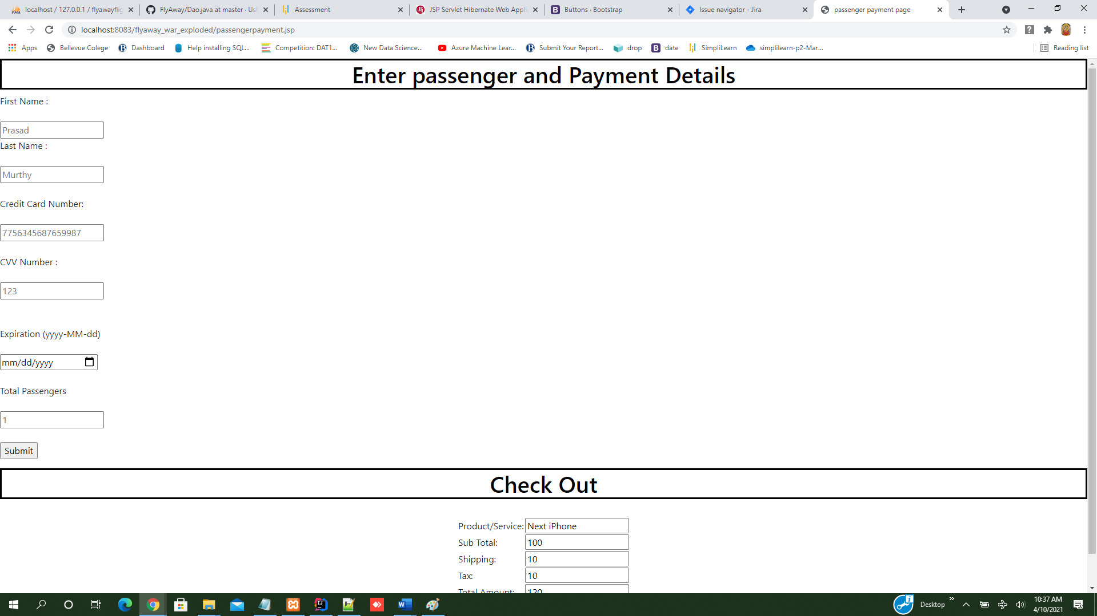

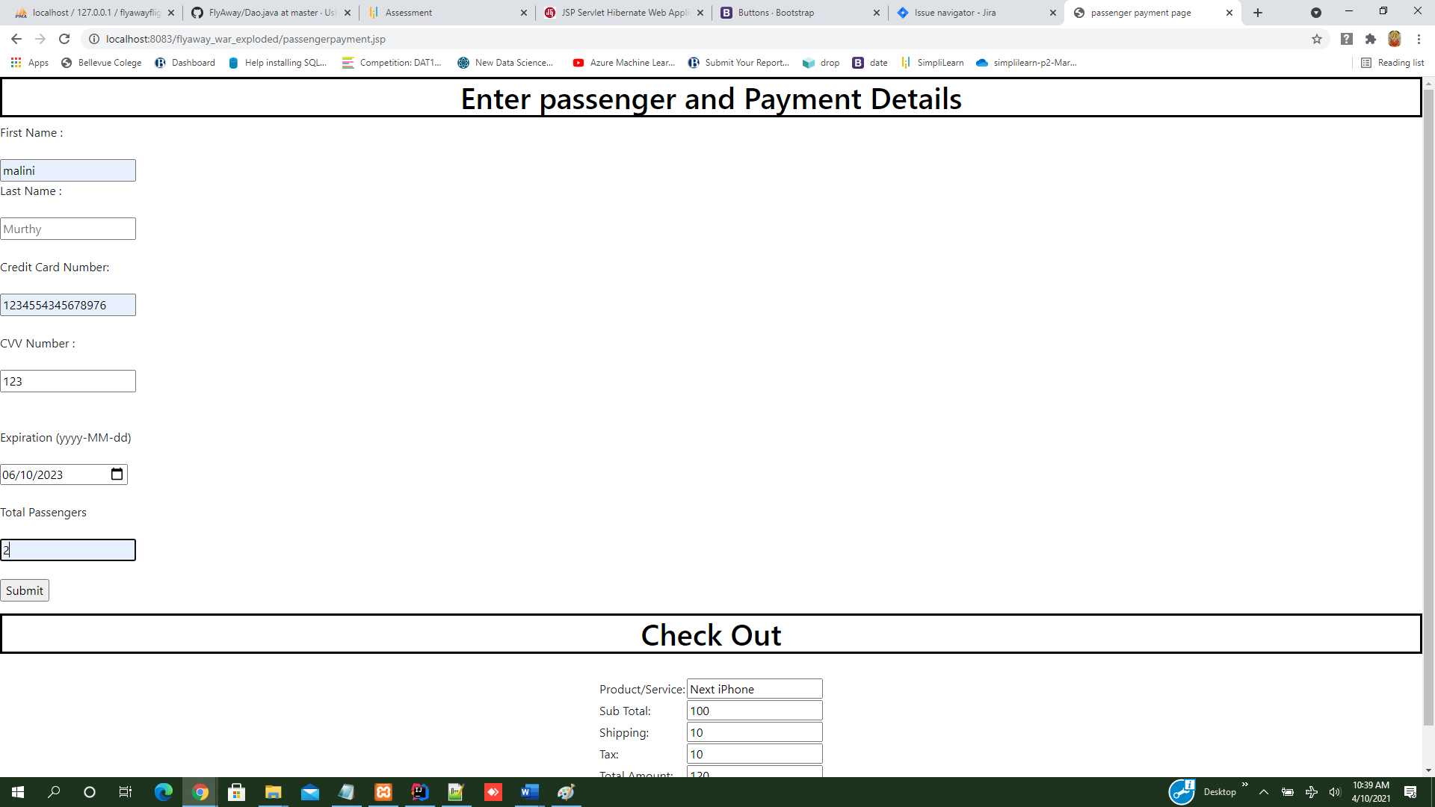

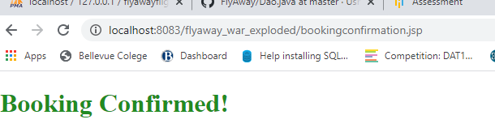

Booking table with inserted confirmed bookings:

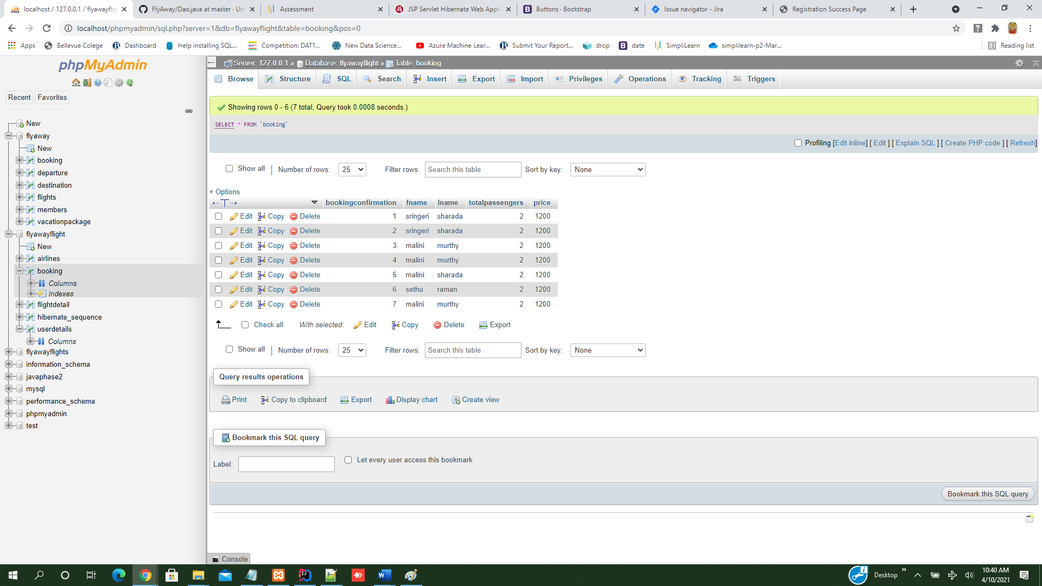

Using paypal sandbox payment gateway integration;

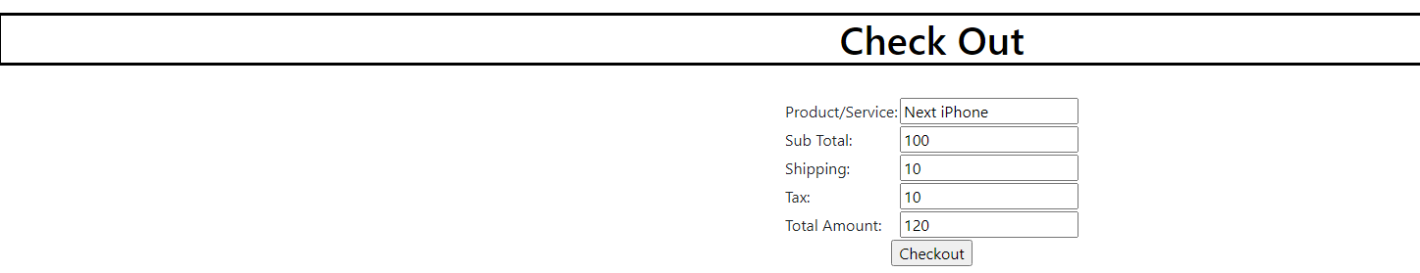

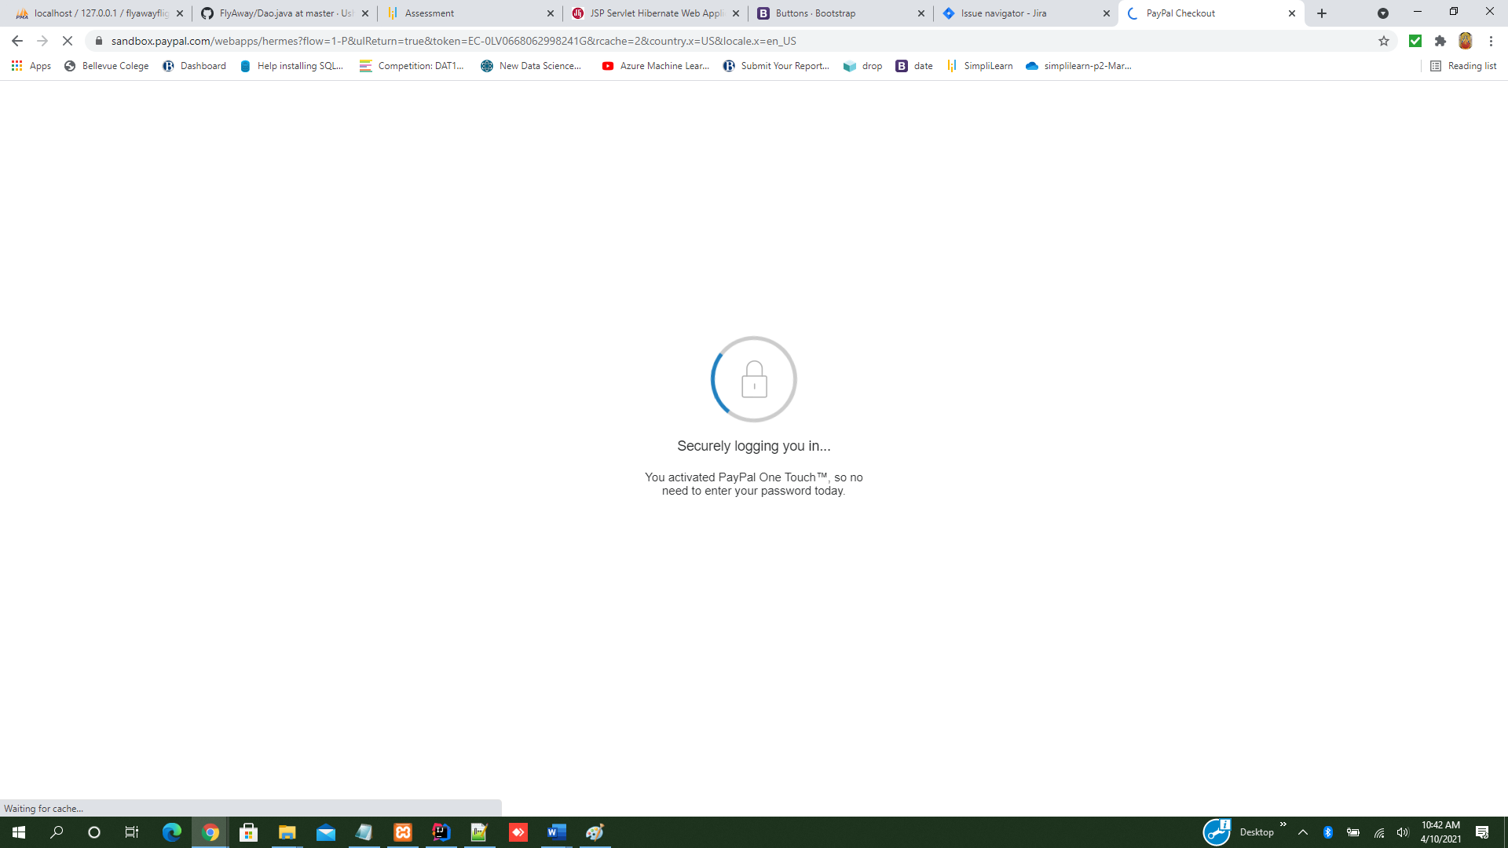

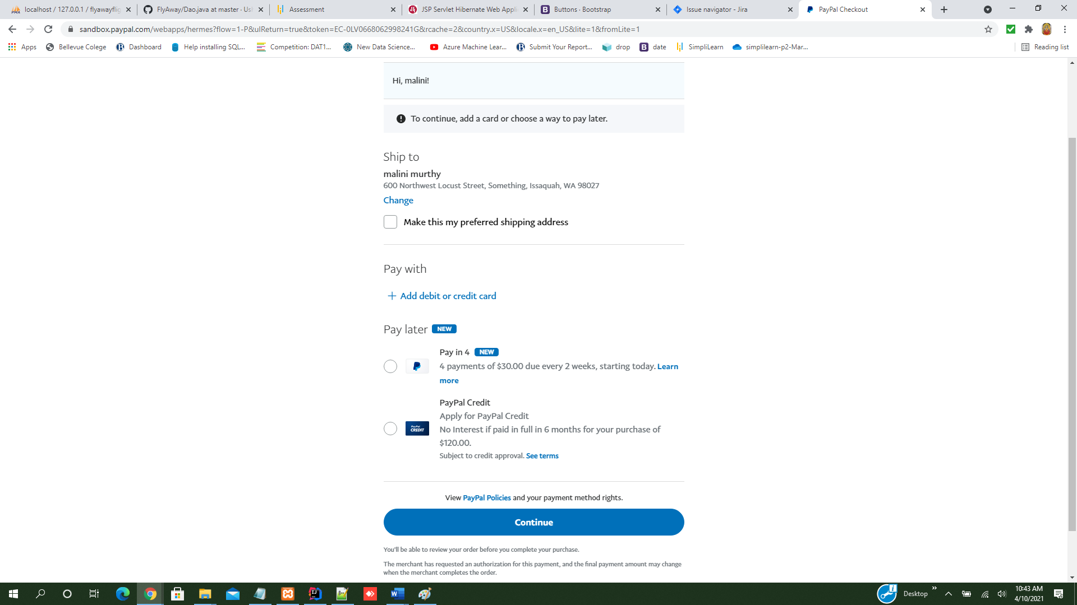

Stopped at this step, else it will make a dummy payment (not passing this step as it asks a credit card and personal information like ssn id which is not to be provided for security and safety reasons

If I proceed below are the steps that user can land on to continue:

Hence created a dummy test credit card with other details as below:

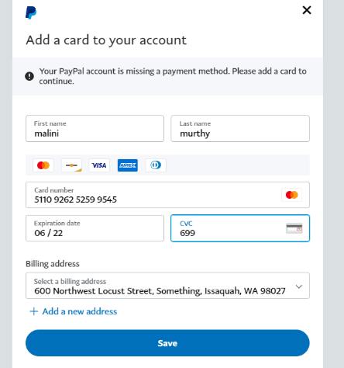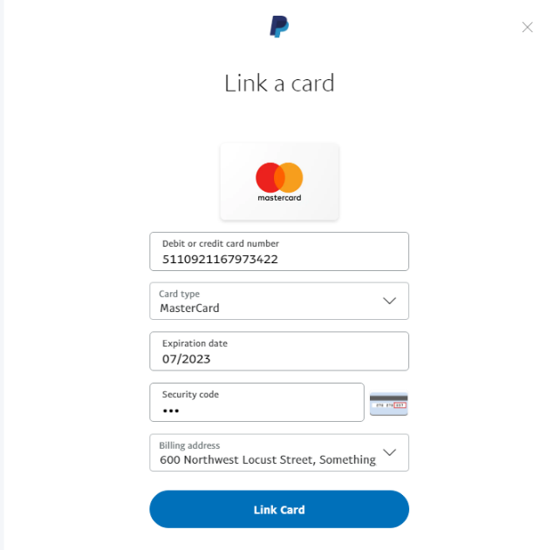

Mapped to third pay webhook simulator

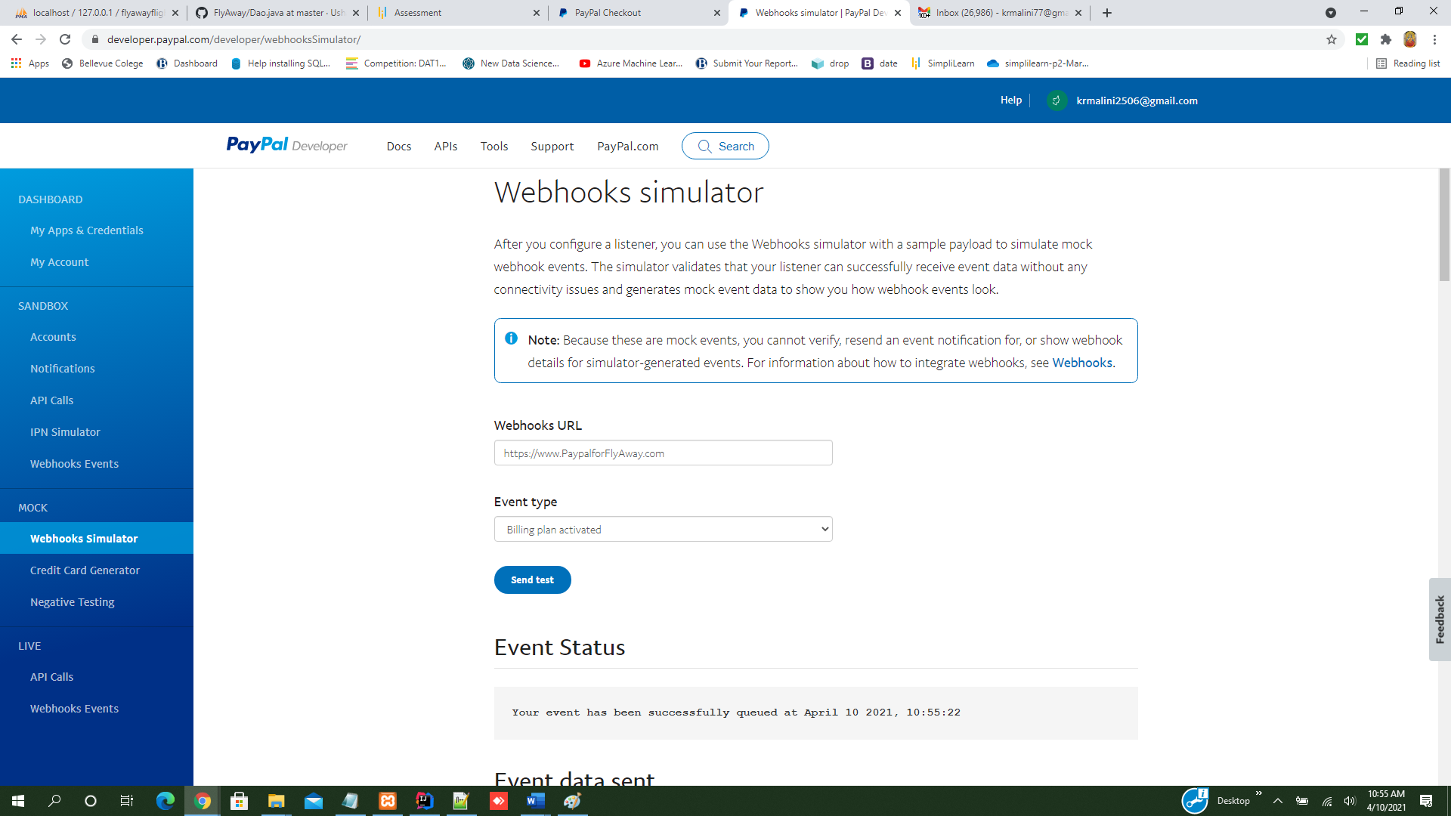

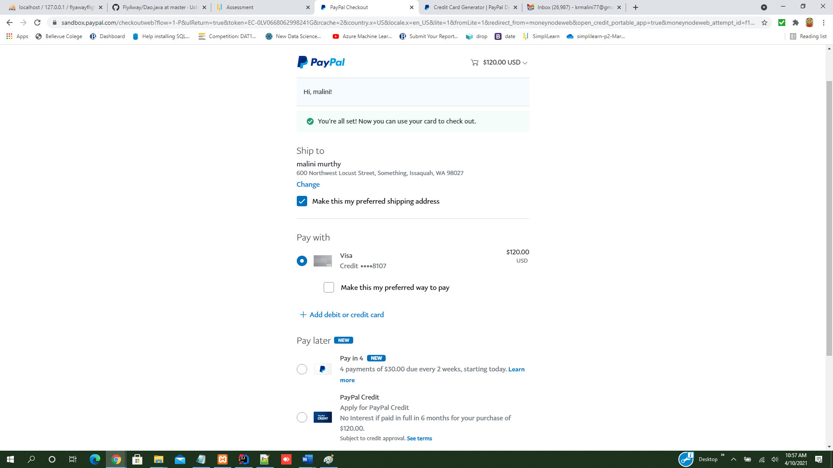

Stopping at this step as my sandbox paypal has no money;

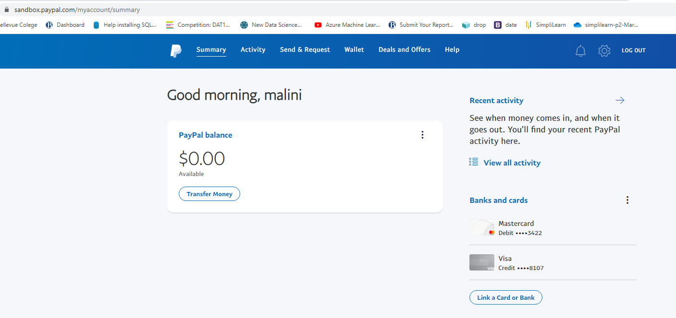

If there is money below screens will be available:

Entering in a wrong client id :

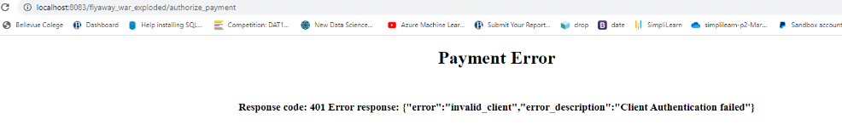

Adding money to paypal balance;

